**Java Assignment-8**

**Creating Custom Java Exception Classes**

By:

Vaibhav Jaiswal

PRN:17070122071

Batch:CS-4

Branch: CSE

SY CSE (Batch of 2017-2021)

**Code**:

**Part -1**

import java.lang.*;

import java.util.*;

class Factorial{

int number ;

public Factorial(){

this.number = 0 ;

}

public Factorial(int number){

this.number = number ;

}

public static int getFact(int number){

int fact = 1 ;

for(int i = 2 ; i <= number ; i++){

fact *= i ;

}

return fact ;

}

}

class MyException extends Exception{

public MyException(String description) {

super(description) ;

}

MyException(){

super("Error Occured") ;

}

@Override

public String toString() {

return super.getLocalizedMessage() ;

}

}

public class Driver

{

public static void main(String args[])

{

int i = 0 ;

for(String k : args){

try{

i = Integer.parseInt(k) ;

if ((i<0 || i >12))

throw new MyException("ERROR :Out of Bounds -> Number : " + i + " -> Not in defined Range") ;

else {

System.out.println("Factorial of " + i + " is " + Factorial.getFact(i));

}

}

catch (MyException ex){

System.out.println("Caught");

System.out.println(ex);

}

catch(NumberFormatException ee){

System.out.println("ERROR ->Number Format Mismatch : please enter correct Input") ;

}

}

}

}

**OUTPUT of Part-1**:

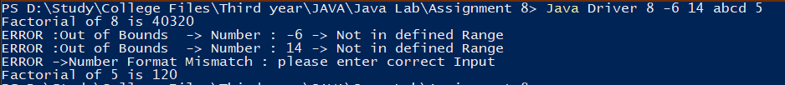

**Part -2**

**Code:**

import java.lang.*;

import java.util.*;

class NOMATCHEXCEPTION extends Exception{

public NOMATCHEXCEPTION(String description) {

super(description) ;

}

NOMATCHEXCEPTION(){

super("Error Occured") ;

}

@Override

public String toString() {

return super.getLocalizedMessage() ;

}

}

class Driver2{

public static void main(String[] args) {

String sample ;

Scanner sc = new Scanner(System.in) ;

System.out.println("Enter a String : ");

sample = sc.nextLine() ;

try{

if(!(sample.equals("India")))

throw (new NOMATCHEXCEPTION(" : String -> "+sample+" is not equal to India"));

else{

System.out.println("Correct input");

}

}

catch(NOMATCHEXCEPTION excp){

System.out.println("Error on Line no :"+excp.getStackTrace()[0].getLineNumber() + excp);

}

sc.close();

}

}

**OUTPUT of Part 2:**

